BPO Datamart Workflow Changes for Automation of SDoH Enrichment
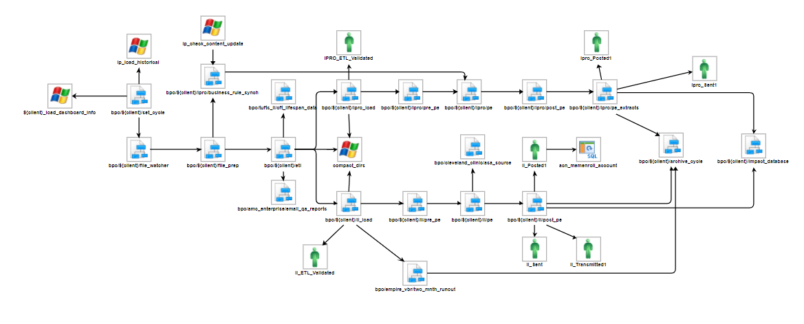

Add Global ‘run_sdoh’ variable and set to ‘N’:
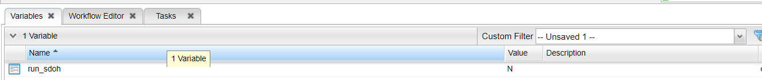
For any client that becomes SDoH enriched, a variable would be added to their datamart trigger – run_sdoh, with the value ‘Y’.
In this way no existing client triggers are required to be updated to account for SDoH tasks in the workflow, only those clients that are, or will become SDoH enriched clients.

Manage Member Roster generation from Input task:

Add tasks to bpo/${client}/etl
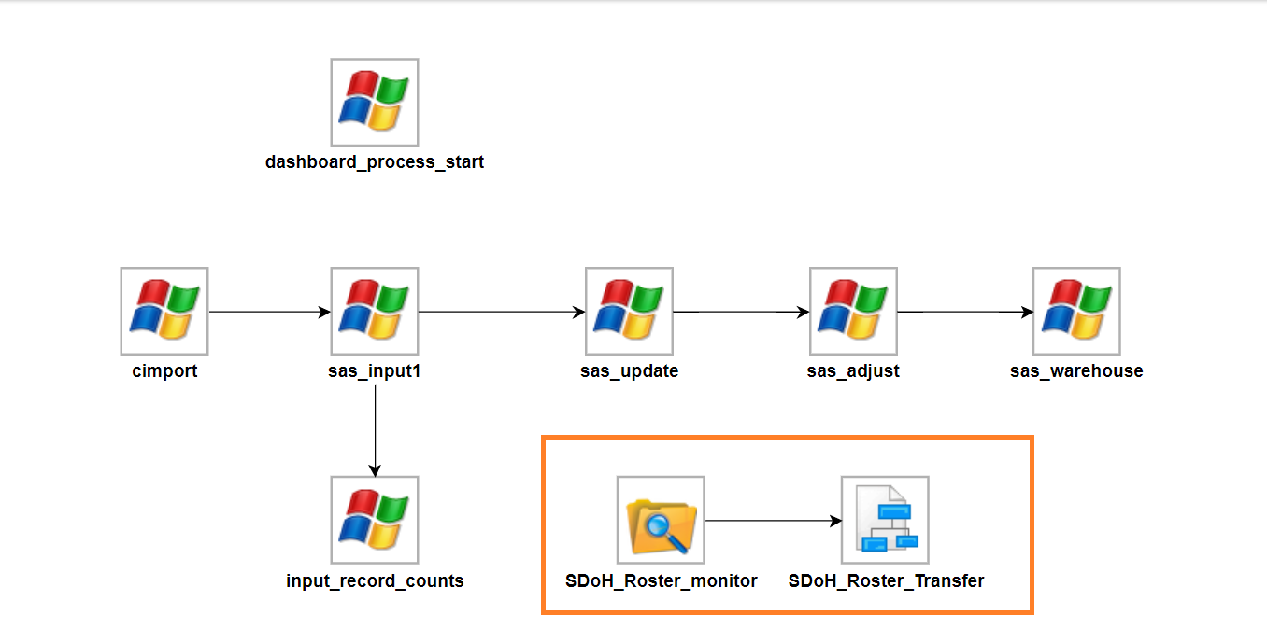

Task Criteria adds to bpo/${client}/etl for SDoH tasks:
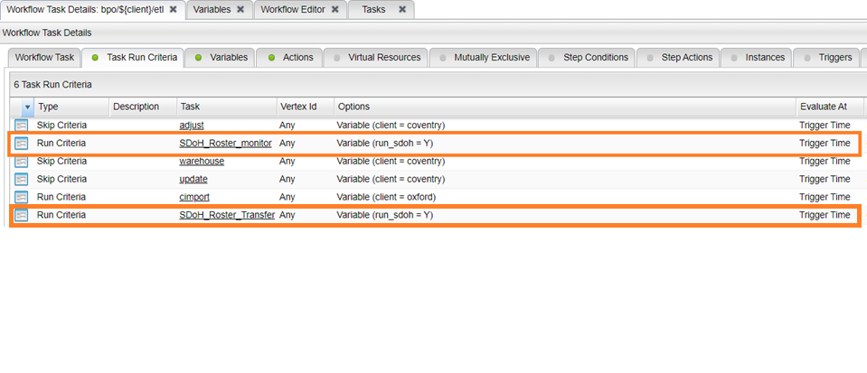

File Monitor Task: SDoH_Roster_monitor
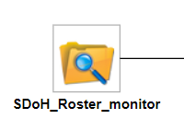
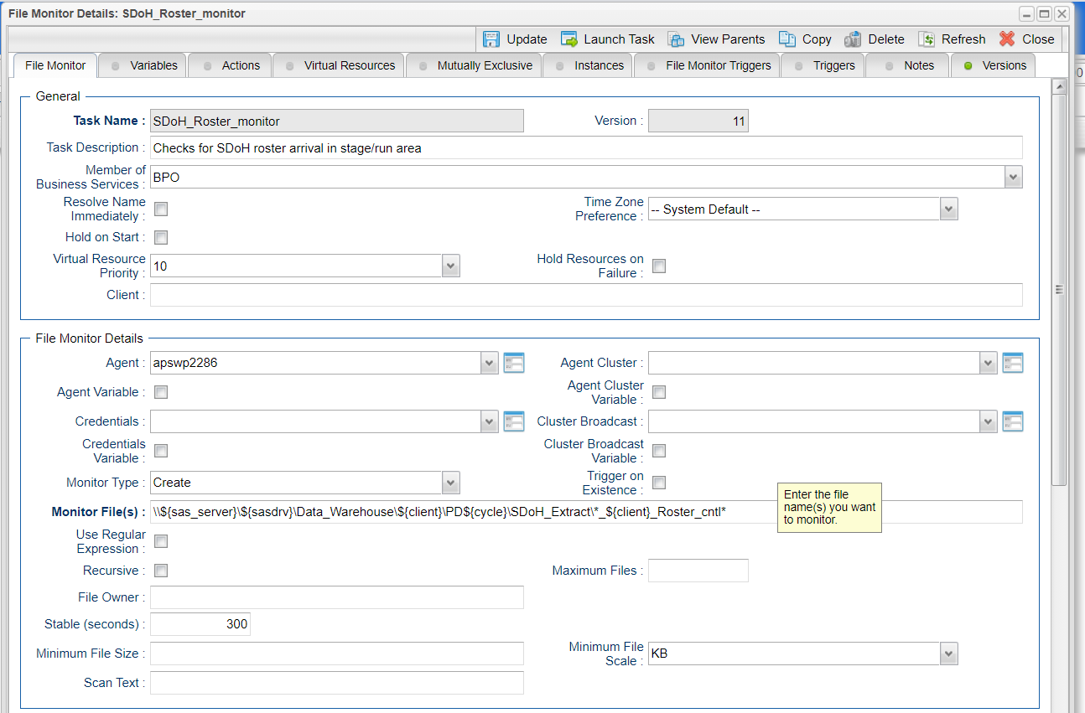

Workflow Task: SDoH_Roster_Transfer:
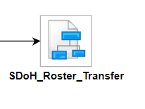
Windows Tasks in SDoH_Roster_Transfer
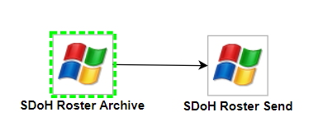

Windows Task SDoH Roster Archive:
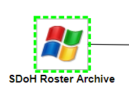
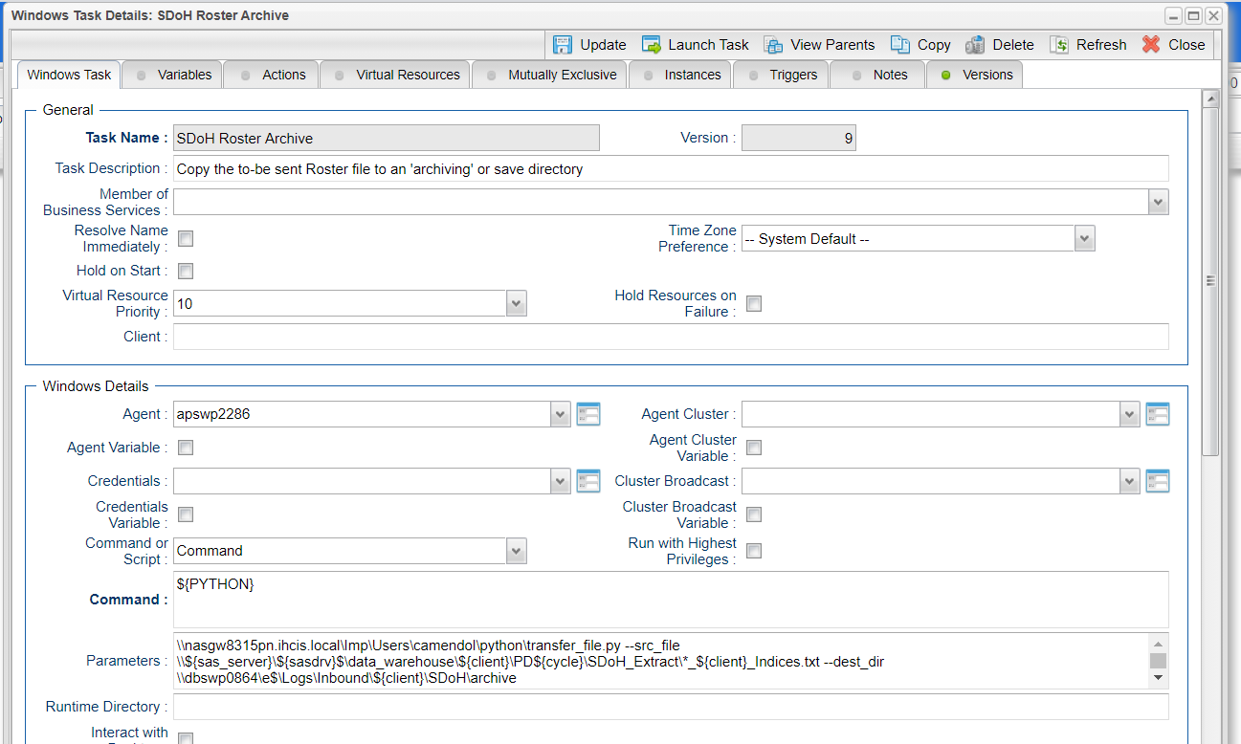
Windows Task SDoH Roster Send:
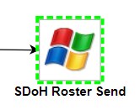
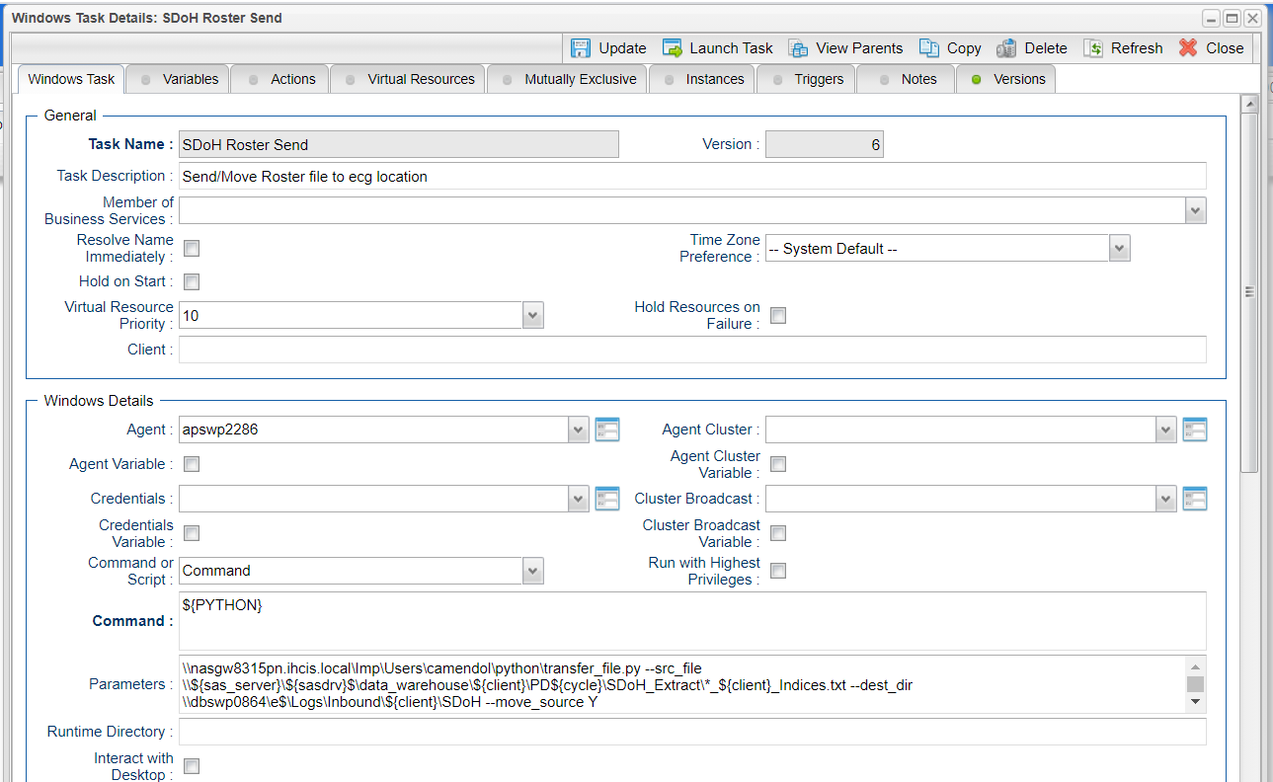

Manage SDoH Enrichment of Data Mart:

Add tasks to bpo/ipro/client/custom:
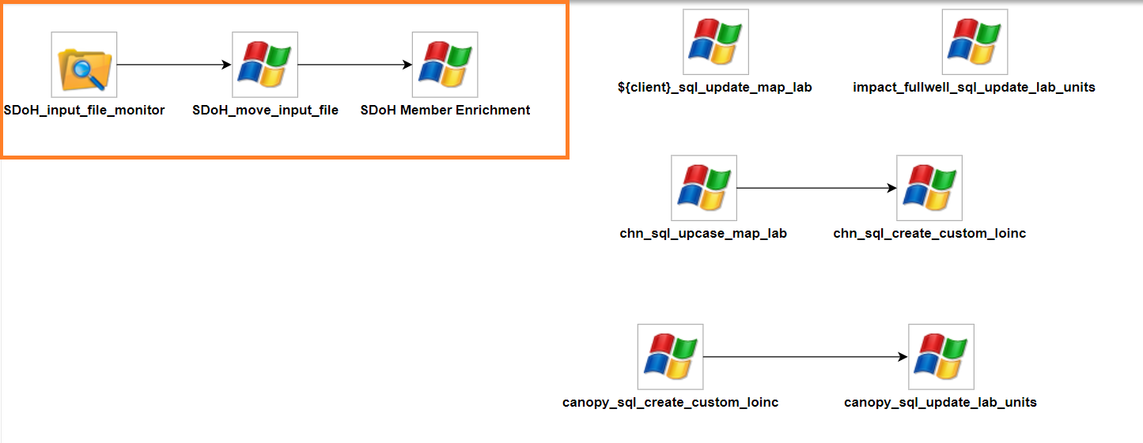

Run task criteria to add to bpo/ipro/client/custom for these new tasks:
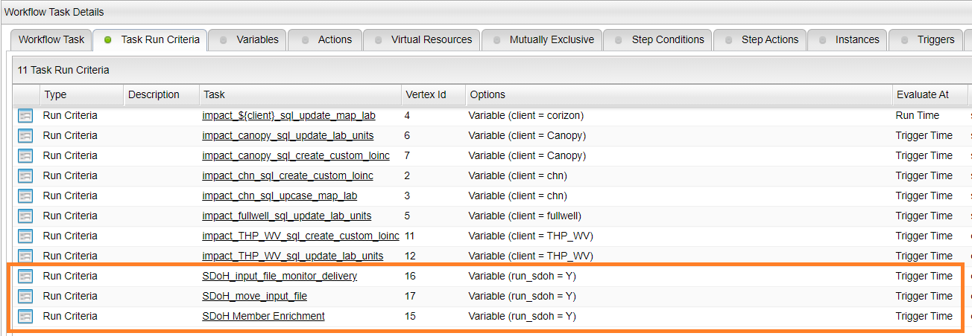

File Monitor Task SDoH_input_file_montior:
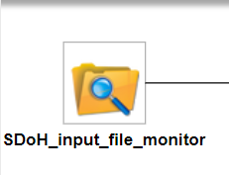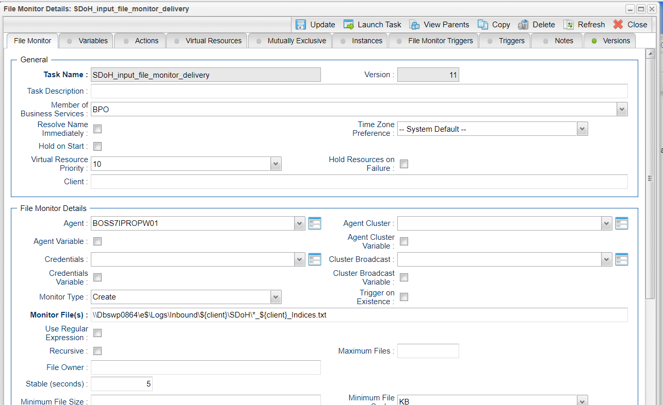

Windows Task SDoH_move_input_file:
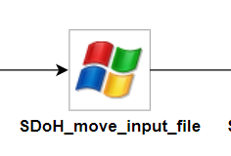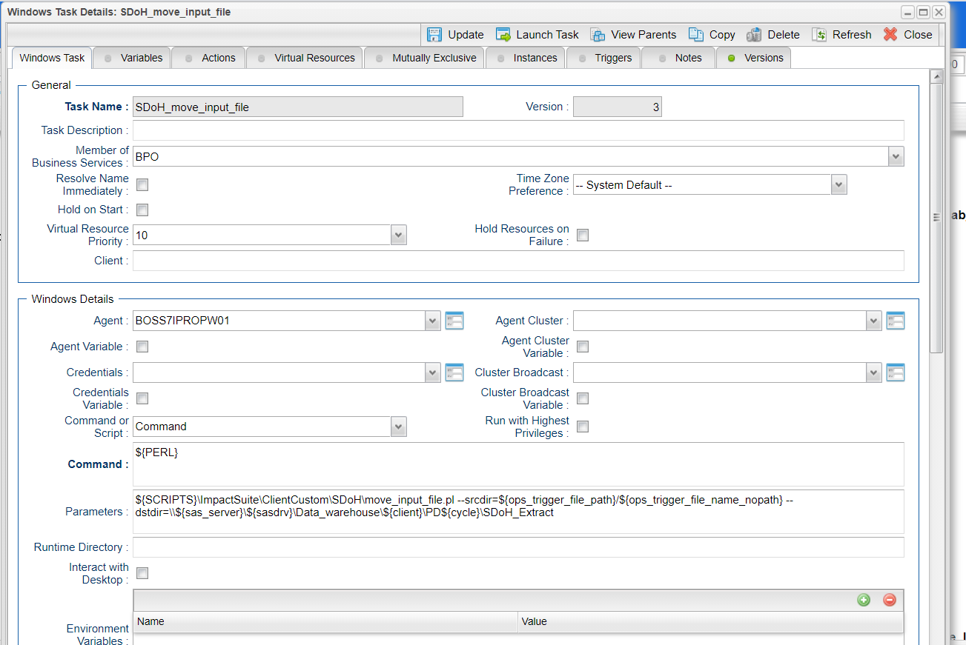

Windows Task SDoH Member Enrichment:
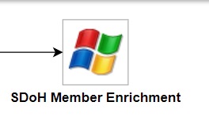
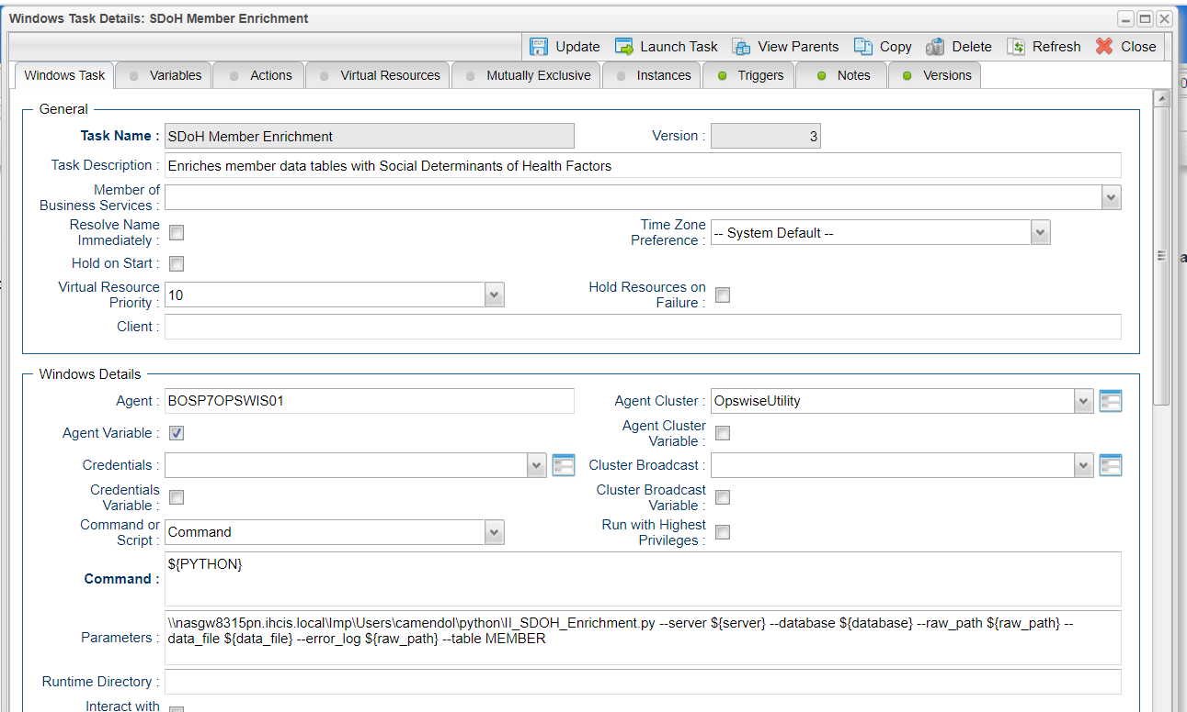

Python Script Details:

II_SDOH_Enrichment.py:
Used in Task SDoH Member Enrichment

usage: II_SDOH_Enrichment.py [-h] -s SERVER -d DATABASE -t TABLE -r RAW_PATH
-f DATA_FILE [-c DELIMITER] [-l {Y,y,N,n}] -e
ERROR_LOG [-o] [-i {II,IPro}]

Social Determinants of Health IPro/II Member Enrichment

optional arguments:
-h, --help show this help message and exit
-s SERVER, --server SERVER
Impact Input Server ID
-d DATABASE, --database DATABASE
Impact Input Database
-t TABLE, --table TABLE
Impact Enrichment Destination Table
-r RAW_PATH, --raw_path RAW_PATH
Path to raw data
-f DATA_FILE, --data_file DATA_FILE
Raw Data File to Load
-c DELIMITER, --delimiter DELIMITER
*C*olumn Delimter
-l {Y,y,N,n}, --skip_header {Y,y,N,n}
Skip Header Row
-e ERROR_LOG, --error_log ERROR_LOG
BCP Error Log Path
-o, --fields_only Create Fields Only
-i {II,IPro}, --impact_type {II,IPro}
Which Impact Product are we using (IPro/II)?

Transfer_file.py:
Used in Task SDoH Roster Archive
Used in Task SDoH Roster Send

usage: transfer_file.py [-h] -s SRC_FILE -d DEST_DIR [-c CREATE_DIR]
[-m MOVE_SOURCE]

File Copy Utility for UAC

optional arguments:
-h, --help show this help message and exit
-s SRC_FILE, --src_file SRC_FILE
Fully specified source file
-d DEST_DIR, --dest_dir DEST_DIR
Destination directory
-c CREATE_DIR, --create_dir CREATE_DIR
Create Destination directory
-m MOVE_SOURCE, --move_source MOVE_SOURCE
Transfer is a move - file deleted from destination

